TITLE
AuraGlass: Smart Glasses System for Visually Impaired Users Using ESP32 and Real-Time Object Recognition

AUTHORS
Afiq Nu’man Bin Ahmad Nazree, Ahmad Nizar Bin Amzah, Datu Anaz Isaac Bin Datu Asrah,
Department of Mechatronics Engineering, International Islamic University Malaysia
Email: ahmadnizar1137@gmail.com

ABSTRACT
This paper details the development of a Smart Glass system designed to assist visually impaired users in real-time navigation and obstacle avoidance. The system employs a multi-tier architecture, where the Master ESP32 manages time-critical sensor readings from the HuskyLens camera, ultrasonic sensor, MPU6050 accelerometer/gyroscope, and a push button, while the Slave ESP32 handles audio outputs via a PAM8403 amplifier, dual speakers, and a piezo buzzer. Wireless communication between the Master and Slave is achieved using ESP-NOW, enabling low-latency transmission of control commands. The system provides speech-based object recognition alerts and distance-dependent obstacle warnings. Experimental evaluation demonstrates reliable detection of obstacles within 100 cm and accurate recognition of predefined objects, ensuring timely feedback for enhanced user safety and situational awareness. The integration of these components validates a robust, wearable, and cost-effective assistive device for visually impaired individuals.
Keywords: Smart Glasses, Visually Impaired, ESP32, HuskyLens, Ultrasonic Sensor, ESP-NOW, Assistive Technology

1. INTRODUCTION
Visual impairment and age-related vision loss considerably affect an individual’s ability to move safely and independently in everyday environments. Visually impaired and elderly individuals frequently face challenges such as detecting obstacles, navigating crowded or unfamiliar spaces, and responding promptly to hazardous situations, particularly under low-light conditions or during emergencies [1]. Conventional assistive devices, including the white cane, are limited to ground-level tactile feedback and are unable to detect frontal or elevated obstacles, thereby increasing the likelihood of collisions and falls [2].
According to the World Health Organization, hundreds of millions of people worldwide live with visual impairment, emphasizing the growing demand for intelligent, accessible, and cost-effective assistive technologies [3]. Studies have shown that the integration of sensors, embedded intelligence, and real-time audio or haptic feedback can significantly improve situational awareness and safety for visually impaired users [4]. However, many existing solutions rely heavily on handheld devices or smartphone-based applications, which may hinder natural movement and reduce system reliability.
In response to these limitations, smart wearable technologies have gained increasing attention as assistive solutions. Among them, smart glasses provide a hands-free and intuitive platform by positioning sensors and cameras near eye level, closely resembling natural human perception. Compared to cane-based systems, smart glasses are more effective in detecting frontal and elevated obstacles such as signboards, poles, and approaching pedestrians. Vision-based intelligent systems have demonstrated strong performance in real-time object detection and recognition, making them suitable for assistive navigation applications [5].
Failure to detect such obstacles has resulted in numerous real-world incidents, including collisions with overhead structures, vehicles, and street infrastructure, especially in poorly illuminated or crowded environments [6]. Elderly individuals are at an even higher risk due to reduced balance, slower reflexes, and increased susceptibility to falls. Moreover, the absence of reliable fall detection and emergency alert mechanisms in traditional assistive tools delays assistance during critical situations, potentially leading to severe injuries or fatal outcomes [7].
To address these challenges, this project proposes AuraGlass, a Smart Glass system that integrates artificial intelligence-based object recognition, ultrasonic distance sensing, motion analysis, and real-time audio feedback into a compact wearable platform. The system employs a dual ESP32 master–slave architecture, where the master ESP32 handles sensor data acquisition, object recognition, fall detection, and decision-making, while the slave ESP32 focuses on generating auditory alerts through a PAM8403 audio amplifier, dual speakers, and a piezo buzzer.
The master ESP32 integrates a HuskyLens AI camera for real-time object recognition, an ultrasonic sensor for obstacle distance measurement, an MPU6050 inertial measurement unit (IMU) for motion and fall detection, and a user button for system control. Fall detection is achieved by monitoring sudden acceleration drops below 0.5 g, followed by a confirmation delay to prevent false positives. If the system detects that the user remains motionless after the event, an emergency alarm is triggered, a Telegram alert is sent to a predefined contact, and the system enters a locked alarm mode that can only be deactivated through a long button press.
Wireless communication between the master and slave ESP32 modules is implemented using the ESP-NOW protocol, enabling fast, low-latency command transmission without requiring internet connectivity. This distributed processing approach reduces computational load, improves responsiveness, and enhances overall system reliability.
Recent advancements in assistive technology demonstrate a clear progression from simple mobility aids to intelligent wearable systems. Early smart canes, such as those proposed by Dey et al. [9], utilized ultrasonic sensors and microcontrollers for basic obstacle detection within short ranges. Gbenga [10] further expanded this concept by introducing a low-cost smart walking stick capable of detecting obstacles at greater distances. Subsequent studies incorporated GPS, IoT connectivity, infrared sensing, water detection, and health monitoring features to enhance user safety and situational awareness [11]–[16].
Despite these developments, many existing systems remain dependent on handheld devices, smartphones, or continuous internet access. In contrast, AuraGlass emphasizes a hands-free wearable design, on-device AI processing, independent fall detection, and real-time audio feedback without smartphone dependency. By combining embedded intelligence, sensor fusion, and distributed ESP32 processing, the proposed system offers a practical and scalable solution that enhances mobility, safety, and independence for visually impaired users.
Table 1 Table of comparison
Ref / Year | Title | Advantages | Disadvantages | Compared to Proposed Smart Glasses
Smart Glasses | Smart Glasses: An Intelligent Vision-Based Assistive Device for the Visually Impaired | AI-based object detection using HuskyLens; hands-free wearable design; real-time audio feedback via speaker; modular MCU–ESP32 architecture | Limited to camera field of view; no physical ground-contact feedback | Provides higher-level environmental awareness, especially for frontal and elevated obstacles
[9] 2018 | Ultrasonic Sensor Based Smart Blind Stick | Low cost; simple obstacle detection using buzzer | Short detection range (5–35 cm); no object recognition; no audio guidance | Proposed system offers vision-based recognition and meaningful audio alerts
[10] 2017 | Smart Walking Stick Using Ultrasonic Sensors and Arduino | Energy efficient; simple and affordable | No emergency, lighting, or intelligent processing | Smart Glasses provide intelligent, context-aware feedback rather than basic distance alerts
[11] 2022 | SCBIoT: Smart Cane for Blinds Using IoT | GPS tracking; obstacle detection; LED indicators | High battery consumption; Wi-Fi dependency | Proposed system is more lightweight, wearable, and does not rely on continuous internet
[12] 2019 | Smart Electronic Stick for Visually Impaired | Uses IR camera and emergency system | App-dependent; cloud/API reliance | Smart Glasses perform onboard AI processing, improving reliability and response time
[13] 2024 | Smart Blind Stick | Health monitoring; water detection; GPS alert | Complex system; higher cost | Proposed system prioritizes simplicity, wearability, and real-time vision feedback
[14] 2018 | Smart Blind Stick Using Arduino | Voice feedback; wearable sensors | App-reliant; no vision-based detection | Smart Glasses enhance accuracy through camera-based AI object recognition
[15] 2021 | GPS and GSM Enabled Smart Blind Stick | Location tracking; vibration alerts | GSM required; complex setup | Proposed system focuses on local intelligence and audio guidance without network dependency
[16] 2018 | Smart Blind Stick for Visually Impaired People | Real-time tactile feedback | Lacks audio, vision, and emergency features | Smart Glasses provide richer multimodal feedback through AI vision and audio

2. METHODOLOGY
2.1 Project Development
AuraGlass: Smart Glass System for Visually Impaired Users Using ESP32 and Real-Time Object Recognition is developed to provide real-time obstacle detection and audio guidance to assist visually impaired users. The system integrates vision sensing, microcontroller processing, and audio feedback to ensure safe and effective navigation.
The AuraGlass consists of several main components, including the HuskyLens camera, ESP32 microcontroller, audio amplifier, and speaker. The HuskyLens continuously scans the front area to detect obstacles and sends the detection data to the ESP32 for processing. Based on the received information, the ESP32 determines the appropriate response and generates an audio alert.
The audio alert system uses a PAM8403 amplifier to enhance the sound signal before transmitting it to the speaker, ensuring clear warning notifications. The system operates continuously after initialization and remains active until the power is turned off.
The overall workflow of the AuraGlass is illustrated in the flowchart, which shows the sequence of system initialization, object detection, data processing, audio feedback generation, and system shutdown. This structured design ensures reliable performance and effective assistance for visually impaired users.
Obstacles
Huskylens AI
(Object Detection)
Ultrasonic Sensor
(Distance Detection)
ESP32 (Master)
Data Processing
ESP32 (Slave)
Decision Logic
Buzzer/Speaker
Fig 1: Block diagram of system 1 & 2
User
(Body Movement)
IMU Sensor
ESP32 (Master)
Fall Detection Algorithm
ESP32 (Slave)
Alert & Network Controller
Telegram Server
(Bot API)
Caregiver Telegram Notification
Fig 2: Block diagram of system 3
Power On
Initialize ESP32 Master:
Huskylens
IMU Sensor
ESP-NOW
Initialize ESP32 Slave:
Speakers
Buzzer
ESP-NOW
Huskylens Scans Area
Is Object Detected?
Send detection data to ESP32 Slave
Yes
Is Distance Detected?
Is fall detected?
No
No
Send detection data to ESP32 Slave
Send detection data to ESP32 Slave
Yes
Yes
No
Object detected
Distance detected
Fall detected
ESP32 processes object information
Generate audio alert
Audio signal sent to PAM8403
Speaker produce sound
ESP32 processes object information
ESP32 processes object information
Buzzer make sound
Notification is sent to telegram
Return to monitoring
Fig 3: Flow chart that explains all the working principles
2.2 Schematic Diagram and Prototype Setup
Fig. 4 illustrates the schematic diagram of the proposed AuraGlass Smart Glass system, which is designed using a distributed ESP32 master–slave architecture to enhance real-time performance and modularity. The master ESP32 serves as the primary control and decision-making unit, interfaced with the HuskyLens AI camera for real-time object recognition, an ultrasonic sensor for obstacle distance measurement, an MPU6050 inertial measurement unit (IMU) for motion and fall detection, and a push button for system control and emergency acknowledgment.
The HuskyLens camera is connected to the master ESP32 via the I²C communication protocol, enabling efficient object classification without the need for external processing units. The ultrasonic sensor provides continuous distance feedback for frontal obstacle detection, while the MPU6050 monitors acceleration and orientation changes to detect fall events based on predefined thresholds. Upon detecting obstacles or abnormal motion patterns, the master ESP32 processes sensor data and determines the appropriate response.
The slave ESP32 is dedicated to audio and alert output and communicates wirelessly with the master ESP32 using the ESP-NOW protocol, ensuring low-latency and reliable data transmission without requiring internet connectivity. The slave ESP32 interfaces with a PAM8403 audio amplifier, which drives two miniature speakers to deliver real-time voice alerts and system notifications. A piezo buzzer is also included to provide distinct warning tones during critical situations such as proximity hazards or detected falls.
Fig. 5 presents the physical prototype implementation of the AuraGlass system. All components are mounted onto a wearable glasses frame, with the HuskyLens positioned at the front to capture the user’s forward field of view. The speakers are placed near the ear to ensure clear and unobtrusive audio feedback, while the electronic modules are arranged to maintain comfort, balance, and portability. This compact and hands-free configuration enables continuous environmental awareness while preserving natural user movement, making AuraGlass suitable for daily use by visually impaired individuals.

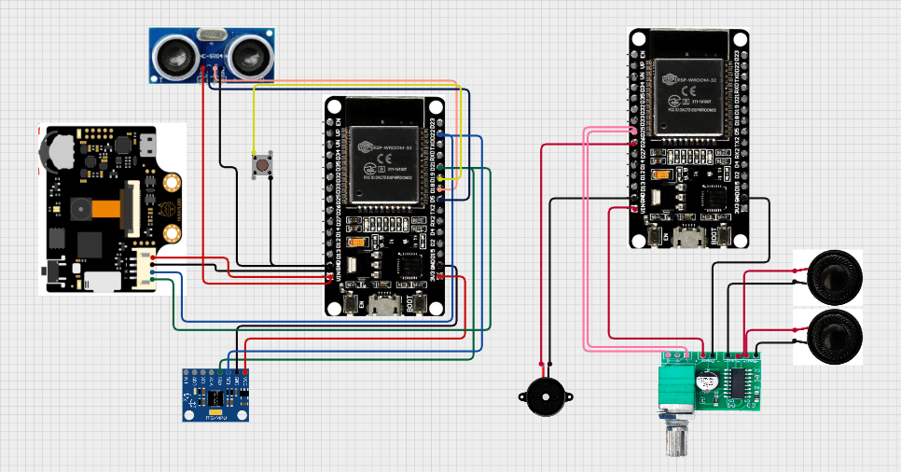
Fig. 4 Schematic diagram of the Smart Glass system

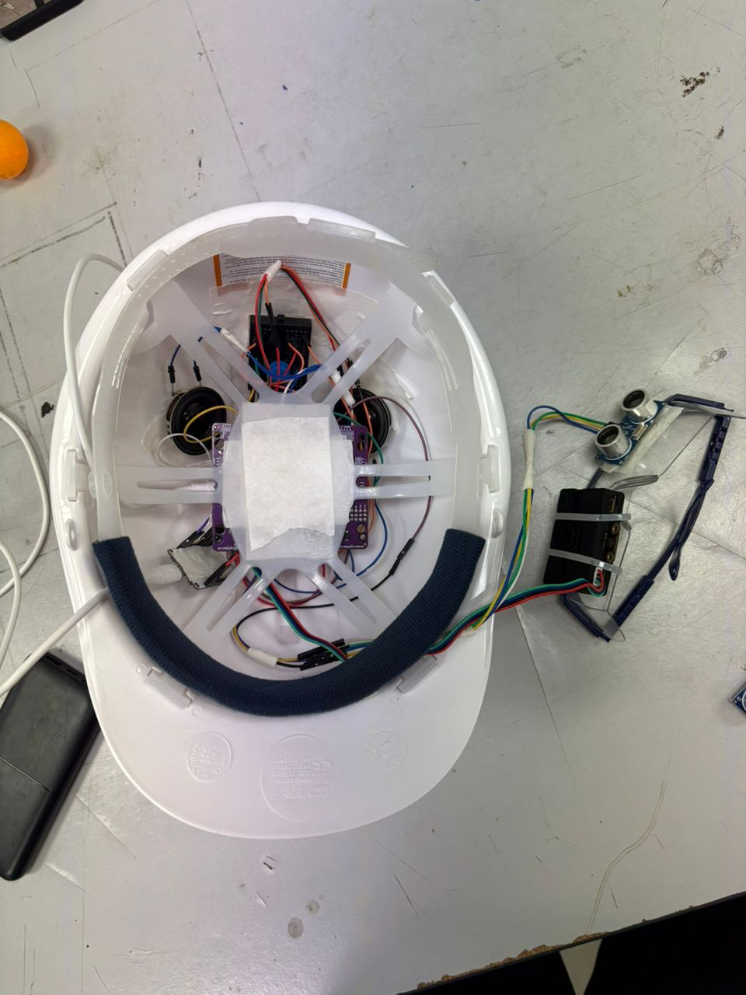
Fig. 5 Smart Glass prototype

3. RESULT AND DISCUSSION
3.1 System Overview and Communication Analysis
The system here proposed consists of two ESP32 microcontrollers configured as Master and Slave, in wireless communication with the use of the ESP-NOW protocol. The Master ESP32 should work with sensor inputs and system logic, while the Slave ESP32 is used to generate audio output, utilizing a PAM8403 amplifier, speaker, and buzzer.
Moreover, the system is integrated with IoT Telegram bot in order to provide notifications about the detected objects and distance alerts in real time directly to the user's smartphone.
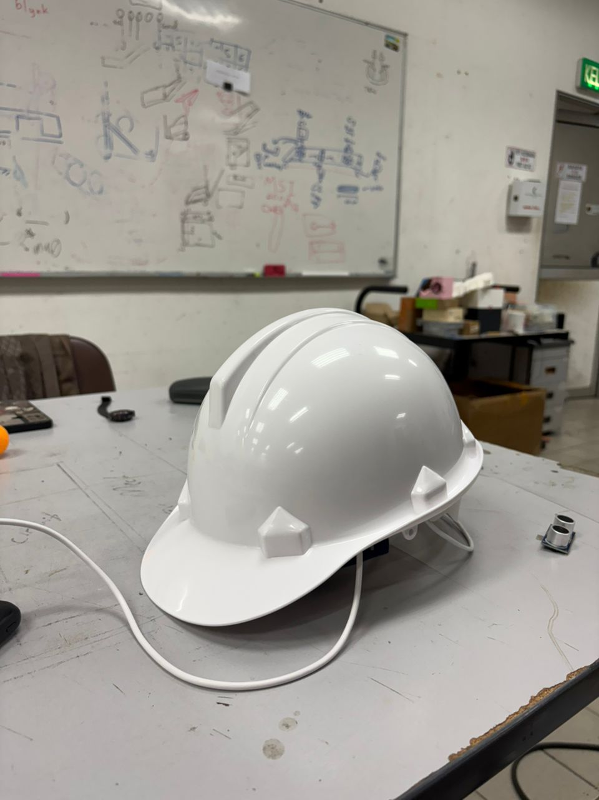
Fig. 3.1: Overall Prototype System Architecture (both ESP32s, sensors, buzzer, speaker, and power supply)
ESP-NOW was chosen because it offers very low latency, peer-to-peer communication, and does not require any routers; hence, this technology fits perfectly in real-time assistive systems. Through experimental testing, it can be concluded that the communication between Master and Slave ESP32s is stable within short-range distances with very small packet loss and fast response time. The notifications via Telegram also arrived with no noticeable delay.

3.2 System 1: HuskyLens Object Recognition Analysis
System 1 works in the HuskyLens object recognition mode; here, the camera detects a trained object and keeps an ID of a pre-set definition. For this project, three object classes were trained:
- ID1: Environment
- ID2: Persons
- ID3: Phone
Once the HuskyLens has detected an object, it sends the recognised ID to the Master ESP32. Then, master does:
- Sends the ID over to Slave ESP32 using ESP-NOW
- Sends the detected ID to the user via Telegram
- Triggers voice output through the speaker

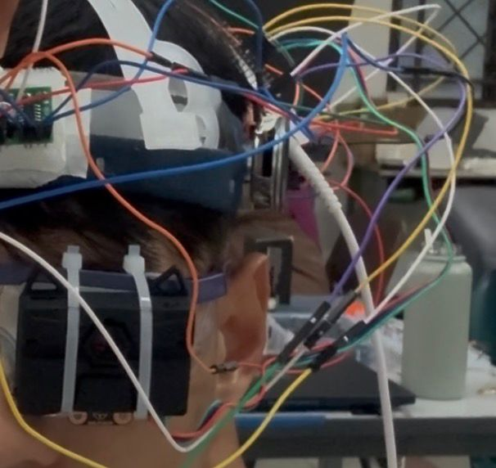
Fig. 3.2: HuskyLens Object Recognition Test Setup
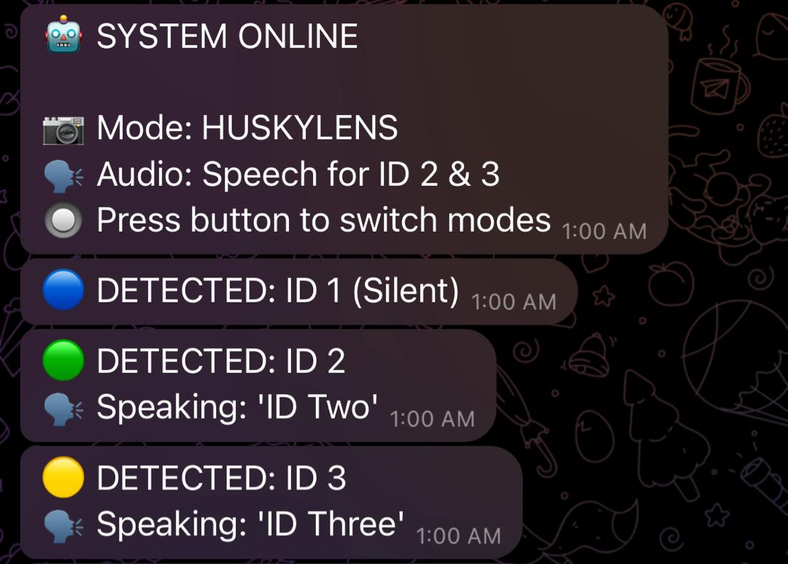
Fig. 3.3: Telegram Notification for HuskyLens Detection
This system could identify objects perfectly when the lighting condition was appropriate. The voice announcement, "ID1," "ID2," or "ID3," was correctly played for most cases to show that object detection, wireless communication, and audio feedback were effectively synchronized. However, recognition accuracy can be influenced by several factors that are not under an individual's control, such as ambient lighting conditions, object distance, and camera alignment-specific limitations of a vision-based system.

3.3 System 2: Ultrasonic Distance Detection Analysis
The ultrasonic system, system 2, turns on when the user clicks the push button to switch to the ultrasonic mode. In this case, the ultrasonic sensor determines the distance between the system and the nearby objects.
When an object has been detected inside the defined distance:
- Master ESP32 sends the alert for the distance to the Slave ESP32
- A buzzer makes a beeping sound, like an reversing beep in a car
- The status of detection is then sent to the user through Telegram

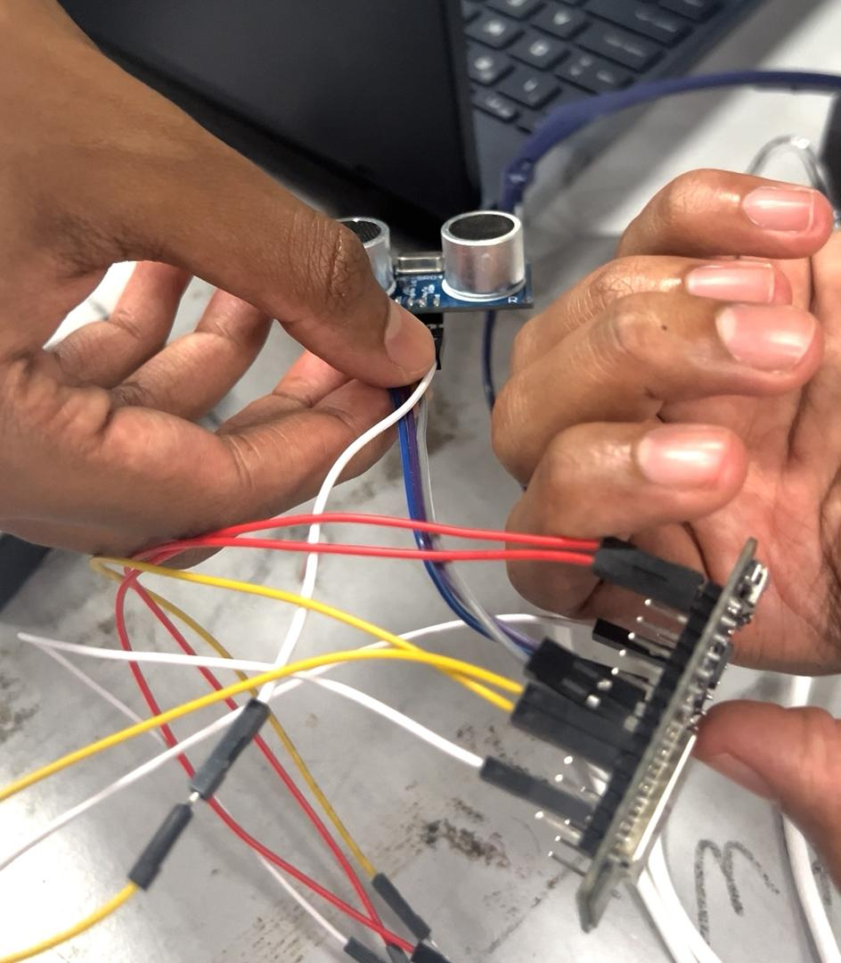
Fig. 3.4: Ultrasonic Sensor Distance Measurement Setup
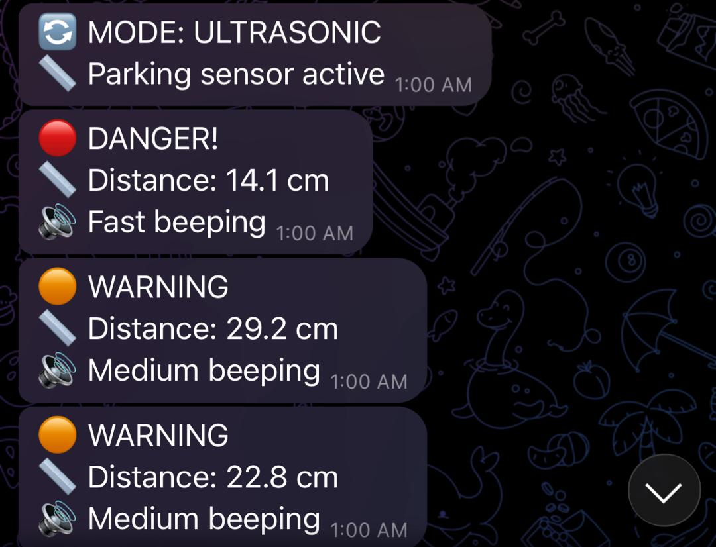
Fig.3.5: Telegram Alert for Distance Detection
The ultrasonic sensor worked satisfactorily when the obstacle was placed directly in front of it. The beeps increased in rate as the object was moved closer, which made it easy to sense proximity. The sensor was dependent on the nature of the surface it was mounted on, which was expected.

3.4 System 3: Fall Detection Using IMU
The fall detection system, System 3, operates continuously to monitor the user’s movement and body orientation using an inertial measurement unit (IMU). The IMU sensor measures acceleration and angular motion to identify abnormal movement patterns that may indicate a fall event.
When a potential fall is detected based on sudden acceleration changes and significant orientation shifts:
- The Master ESP32 processes the IMU data and determines whether a fall has occurred
- A fall alert signal is transmitted wirelessly from the Master ESP32 to the Slave ESP32 using ESP-NOW communication
- The Slave ESP32 connects to the internet and sends an emergency notification to the caregiver or user via the Telegram platform
This system enhances user safety by providing real-time monitoring and immediate alerting in the event of a fall, allowing for prompt assistance and reducing the risk of serious injury.

3.5 Mode Switching Analysis Using Push Button
A push-button interface was added, which helps the user toggle between the HuskyLens mode and Ultrasonic mode without needing to reboot the entire system. The state of the entire system switches with every click of the buttons.
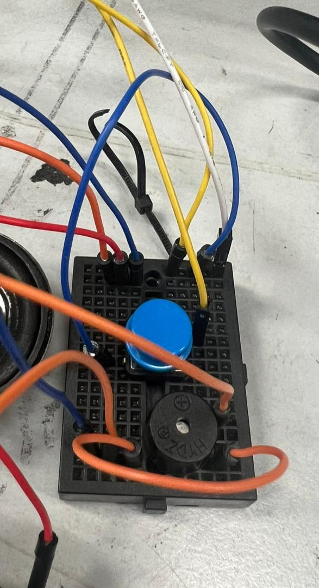
Fig. 3.6: Push Button Integration and Mode Switching Mechanism
Testing the mode-switching function revealed it to be reliable. There are minor delays caused by the button debouncing effect, but such delays are insignificant to the system’s performance as a whole. The simpler mode-switching function greatly enhances user convenience and usability.

3.6 Audio Output Analysis at Slave ESP32
The Slave ESP32 is responsible for the control of all alert signals, which include:
- Voice announcements through PAM8403 Speaker Module
- Alarm signals through the beeper for warning of distance
In the HuskyLens mode, the speaker calls out the object ID. In the ultrasonic mode, the buzzer does a beep similar to car parking sensors when the object gets closer.
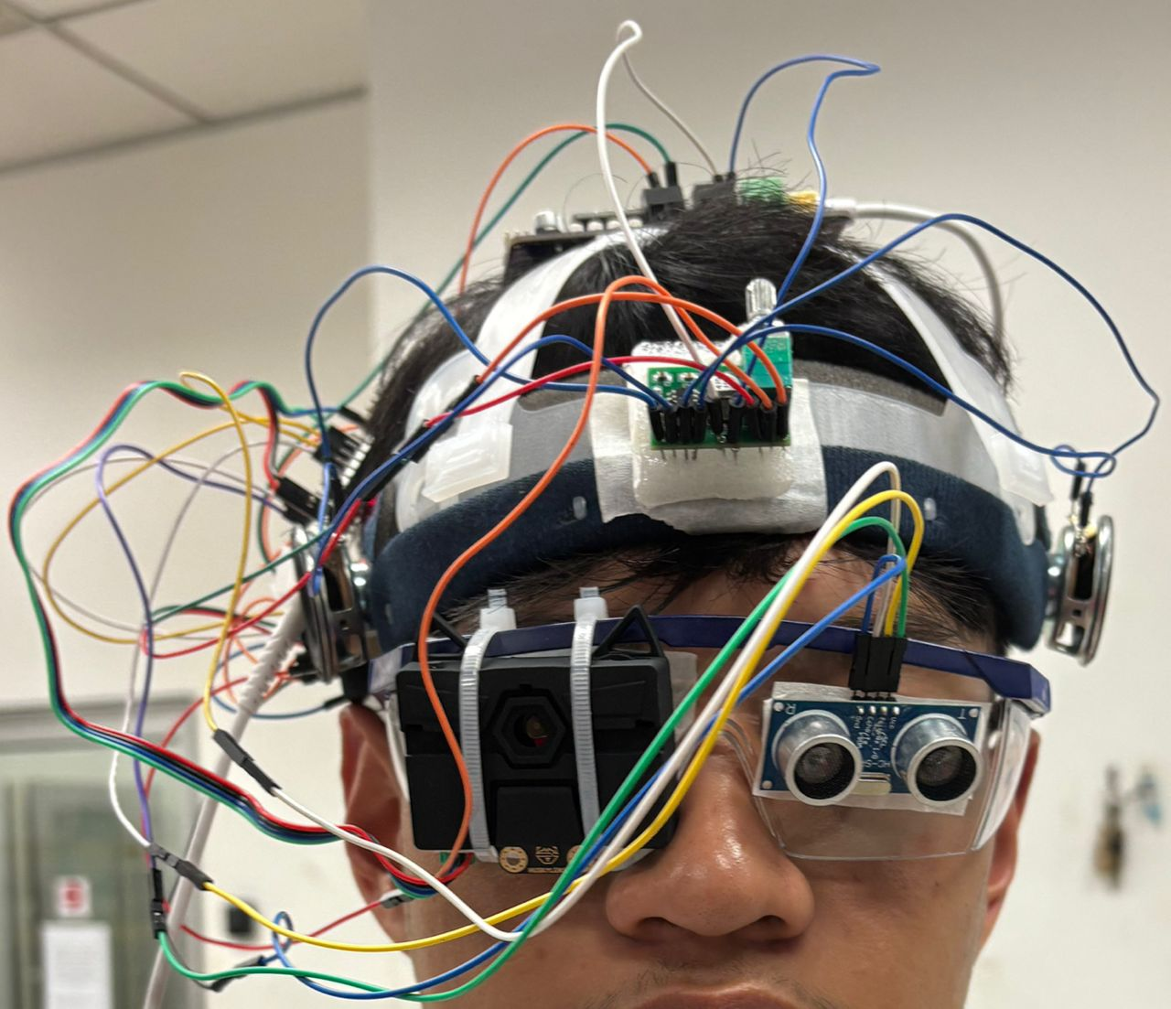
Fig. 3.7: Front Panel
On the audio alert notifications, they could be easily identified in either of the modes. With the addition of notification services offered by the Telegram application, it can be considered a very reliable system.
Mode of Operation | Sensor Used | Detected Condition | Data Sent via ESP-NOW | Local Output | Telegram Notification
HuskyLens Mode | HuskyLens | Surroundings | ID1 | None | “Clear”
HuskyLens Mode | HuskyLens | People | ID2 | “ID2” voice | “Person Detected”
HuskyLens Mode | HuskyLens | Phone | ID3 | “ID3” voice | “Phone Detected”
Ultrasonic Mode | Ultrasonic Sensor | Object within threshold | Distance Alert | Beep sound (Reverse-car style) | “Object Nearby”
Emergency Mode | MPU6050 (IMU) | Fall detected with inactivity | Fall Alert | Continuous alarm | “Fall Detected”
Table 3.1 Enhanced Operational Modes and System Response Summary

No. | System Function | Sensor / Input Module | Processing Unit | Trigger Condition | Output / System Response
1 | Object Recognition | HuskyLens AI Camera | ESP32 (Master) | Recognized object ID detected | Voice announcement via speakers
2 | Obstacle Distance Detection | Ultrasonic Sensor | ESP32 (Master) | Distance below predefined threshold | Warning tone via piezo buzzer
3 | Mode Switching | Push Button | ESP32 (Master) | Button press | Switch between object recognition and obstacle alert modes
4 | Audio Feedback Control | ESP-NOW Command | ESP32 (Slave) | Command received from master | Speech output via PAM8403 & speakers
5 | Proximity Alert | Ultrasonic Sensor | ESP32 (Master → Slave) | Continuous close-range detection | Repetitive buzzer alerts
6 | Fall Detection | MPU6050 (IMU) | ESP32 (Master) | Sudden acceleration drop (< 0.5g) followed by inactivity | System enters alarm mode
7 | Emergency Alert | MPU6050 + Timer | ESP32 (Master) | Fall confirmed after 3-second delay | Telegram notification sent
8 | Alarm Lock State | System Logic | ESP32 (Master) | Emergency triggered | Continuous audio alarm
9 | Alarm Reset | Push Button | ESP32 (Master) | Long press (≥ 3 seconds) | Alarm deactivated, system reset
Table 3.2 System Functionality and Output Summary

3.7 Overall Discussion
Based on the experimental observations and system evaluation, the proposed AuraGlass Smart Glass system successfully integrates real-time object recognition, distance sensing, inertial-based fall detection, wireless communication, and audio feedback within a compact wearable platform. The adoption of a dual ESP32 master–slave architecture enables effective task distribution, where sensor fusion and decision-making are handled by the master unit while audio alert generation is delegated to the slave unit. This design significantly reduces processing overhead and contributes to improved system responsiveness.
The use of the ESP-NOW communication protocol demonstrates reliable and low-latency data transmission between the master and slave ESP32 modules without requiring continuous internet connectivity. This is particularly advantageous for wearable assistive devices, where real-time feedback is critical. Furthermore, the integration of Telegram-based notifications enhances system functionality by enabling remote emergency alerts during critical events such as fall detection, thereby extending the system’s applicability beyond immediate local feedback.
The combination of HuskyLens AI-based object recognition and ultrasonic distance sensing provides complementary sensing capabilities. While the HuskyLens enables intelligent identification of objects in the user’s forward field of view, the ultrasonic sensor offers continuous proximity information for obstacle avoidance. This sensor fusion approach improves environmental awareness compared to systems relying on a single sensing modality. However, variations in lighting conditions, object reflectivity, and environmental noise can influence detection accuracy, highlighting the importance of calibration and adaptive thresholding.
The MPU6050-based fall detection mechanism further enhances user safety by monitoring sudden acceleration changes followed by inactivity, enabling reliable identification of fall events. Once triggered, the system enters an alarm state, activates audio alerts, and sends emergency notifications, ensuring timely assistance. Although the current implementation performs effectively at the prototype level, further testing with diverse user motion patterns is necessary to reduce false positives and improve robustness.
Overall, the AuraGlass system demonstrates strong potential as an intelligent, hands-free assistive technology for visually impaired users. While environmental constraints and hardware limitations present areas for refinement, the prototype validates the feasibility of integrating artificial intelligence, sensor fusion, and wireless communication within a wearable smart glass platform. Future improvements may include power optimization, miniaturization, and expanded object recognition capabilities to further enhance usability and real-world deployment.

4. CONCLUSION
To sum up, the Smart Glasses for the Blind have successfully met their objective of developing a practical and effective assistive device for visually impaired users by integrating key features such as object detection using HuskyLens, fall detection through an inertial measurement unit (IMU), and emergency alert mechanisms via Telegram notification. The system utilizes ESP32 microcontrollers with ESP-NOW wireless communication to ensure fast and reliable data transmission between system components. This project has demonstrated the practical application of Internet of Things (IoT) and embedded systems technologies, while also enhancing technical knowledge in sensor integration, circuit implementation, wireless communication, and user-centered system design.
Based on the current implementation, the developed prototype provides a strong foundation for future improvements. Advanced sensing technologies such as LiDAR for more accurate distance measurement, real-time GPS tracking integrated with cloud-based platforms, voice feedback systems, and improved power management solutions including rechargeable or solar-assisted charging can be incorporated to further enhance system performance and usability. Additionally, future versions may benefit from lightweight and ergonomic mechanical designs for improved user comfort. Incorporating adaptive learning techniques and artificial intelligence could further personalize the system, improving detection accuracy and making the smart glasses a more intelligent, efficient, and user-friendly mobility aid.
Acknowledgement
The authors would like to thank the Mechatronics System Integrations laboratory staff for providing the necessary components, facilities, and technical support required for the successful completion of this project.
Conflict of Interest
Authors declare that there is no conflict of interest regarding the publication of the paper.
Author Contribution
The author attests to having sole responsibility for the following: planning and designing the study, data, collection, analysis and interpretation of the outcomes, and paper writing.

Reference
[1] Assistive systems for visually impaired people: A survey on current technologies, ScienceDirect. Available: https://www.sciencedirect.com/science/article/abs/pii/S0925231224010555

[2] Intelligent Cane for Assisting the Visually Impaired, MDPI. Available: https://www.mdpi.com/2227-7080/12/6/75

[3] SMART GLASSES FOR THE VISUALLY IMPAIRED, IRJMETS. Available: https://www.irjmets.com/upload_newfiles/irjmets71100078523/paper_file/irjmets71100078523.pdf

[4] Gravity: HUSKYLENS AI Machine Vision Sensor, Arduino Store. Available: https://store-usa.arduino.cc/products/gravity-huskylens-ai-machine-vision-sensor

[5] Gravity: Huskylens AI Vision Sensor, SparkFun Electronics. Available: https://www.sparkfun.com/gravity-huskylens-ai-vision-sensor.html

[6] The white cane and beyond: wearable assistive navigation technologies, Optometry Times. Available: https://www.optometrytimes.com/view/beyond-the-white-cane

[7] Smart Glasses for Blind Prototype, Arduino Project Hub. Available: https://projecthub.arduino.cc/snehiludrhj/smart-glasses-for-blind-prototype-3eb649

[8] HuskyLens AI Vision Sensor Documentation, DFRobot, 2023. Available: https://www.dfrobot.com

[9] Espressif Systems, “ESP-NOW Wireless Communication Protocol,” Espressif Systems, 2023. Available: https://docs.espressif.com

[10] Telegram Bot API Documentation, Telegram Messenger LLP, 2023. Available: https://core.telegram.org/bots/api

